ENGLISH FIRST PEOPLES 10

Pattison High School
Spring Semester 2023 (May-August 2023)
Ms. Subramaniam
We recognize that our learning takes place on the traditional territories of the
Squamish, Musqueam, and Tsleil-Waututh people.

Link to B.C. Ministry of Education Curriculum for this course
https://curriculum.gov.bc.ca/sites/curriculum.gov.bc.ca/files/curriculum/english-language-arts/en_english-language-arts_10_efp-literary-studies_elab.pdf
Important note about this course:
English First Peoples does not require a prior understanding of Indigenous Canadian history or language. In this class, you will not be required to read texts in an Indigenous language, although we will be exposed to Indigenous linguistic components in our class. English First Peoples is an exploration of short stories, poems, oral narratives, and historical information about Indigenous communities in Canada, which will be conducted in English.
A respect for Indigenous knowledge, history, and people, is essential to this course, as is an openness to learn. Prior knowledge is not required to explore Indigenous content, although it is highly welcomed.
Although much research and learning has gone into the creation of this course, and I am constantly updating my knowledge, it is important to keep in mind that there is an ocean of information waiting for us.
Additionally, I am not an expert on Indigenous matters, especially since this area of study has long been neglected in the history of our country, unfortunately. The teacher and the class will be learning and exploring together, and it is important to note that I am not a representative of and do not speak for any Indigenous people.
Furthermore, this course deals heavily with sensitive issues such as colonization, genocide, discrimination, and human rights violations. Please feel free to speak with me or the counsellor if any of these issues overwhelm you. I will try my best to discuss these topics while keeping in mind the needs of every student present.
It is with deep respect, and an understanding of the sacred nature of certain Indigenous components, that we move forward together in this class.

-Ms.S

Course Description
EFP Literary Studies 10 is designed for students who are interested in exploring First Peoples literature in a variety of contexts, genres, and media. This area of choice provides students with opportunities to explore personal and cultural identities, histories, stories, and connections to land/place. This course is grounded in the understanding of how texts are historically and culturally constructed. Students will work individually and collaboratively to broaden their understanding of themselves and the world.
The following are possible areas of focus within EFP Literary Studies 10:

• Thematic study of First Peoples literature (e.g., family, humour, connection to land, resistance, belonging, identity)
•Locally developed First Peoples texts
•Specific First Nations, Métis, or Inuit author study
•First Peoples children’s literature
•Storytelling in a First Peoples context

What will we cover in this course?
This list is not extensive and may change. The main topics covered in this class include, but aren’t limited to:

- An understanding of important historical and current developments in Indigenous studies, such as Truth and Reconciliation, Residential Schools, and Treaty Rights.
- Articles by Indigenous authors relating to personal or family experiences, or opinion pieces.
- Videos, documentaries, and other multimedia that explore Indigenous experiences.
- Concepts, artifacts, and ideas such as Sharing Circles, Oral Narratives, and Wellness Circles.
- A novel unit (The Marrow Thieves by Cherie Dimaline)
- Indigenous artwork
- Short stories or poems by various authors.

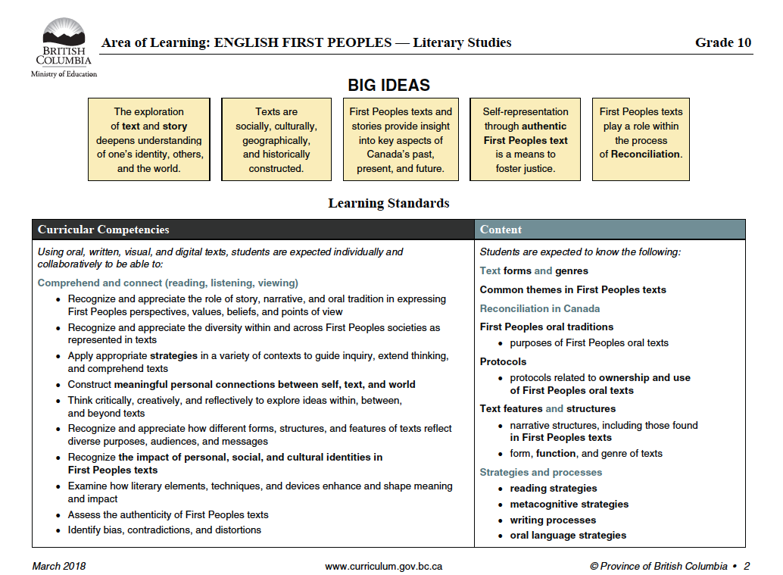

Evaluation Scheme
Quizzes and Tests  15% | Participation  10% | Final  20% | Midterm  20% | Note checks, classwork, or homework  5% | Assignments and Projects  30%
*Important note about the Evaluation Scheme: This semester has an amended evaluation scheme. The Evaluation Scheme is not the same as some previous semesters, so please familiarize yourself with it.

Important points to remember:

- Plagiarism negates points!
- Remember to raise your hand in class.
- Participation must be productive, not destructive. Just speaking all the time in class does not qualify as productive participation. Your participation must contribute something positive to the discussion and not distract the class. You must also practice active and attentive listening. Listening to others is just as important as speaking.
- Disagreeing with someone is completely acceptable, as long as you focus on the idea and not the person.
- We respect people of all backgrounds in this class. Please keep this in mind. Bullying is any form is not tolerated.

Additional Guidelines:

- ATTENDANCE & PUNCTUALITY
- Be on time and notify the teacher when you will be absent. Do not ever leave campus without permission during school hours in-case of an emergency.
- If you are sick, notify the teacher via email and do not come to class. You will require proof of sickness in the form of a note that is either signed by your parent, home-stay guardian or a doctor. You must also leave a contact number for the person who signs the note for verification purposes.
- PLAGIARISM AND ACADEMIC DISHONESTY
- Plagiarism and academic dishonesty cannot be tolerated under any circumstance. From the Teacher’s perspective, it is very simple to recognize when a student is not using original work. If you do not understand how NOT to plagiarize, please speak to me privately so I can show you! Multiple occurrences must and will be reported to the principal.
- MISSED WORK & GRADES
- Ultimately, if you have missing work your grades will be negatively affected. I will always give students the chance to make up work (within reasonable circumstance) to earn better marks. However, be prepared to defend your position as to why you should have the privilege to re-do, complete extra or make up missed work. If you miss a course-work deadline and subsequently skip your make-up date, you will be awarded a zero – no exceptions.

For more information, please email Ms.Subramaniam at jyotsna.subramaniam@pattisonhighschool.ca

