ENGLISH STUDIES 12

Pattison High School
Spring Semester 2022 (May-August 2023)
Ms. Subramaniam

We recognize that our learning takes place on the traditional territories of the Squamish, Musqueam, and Tsleil-Waututh people.

Link to B.C. Ministry of Education Curriculum for this course
https://curriculum.gov.bc.ca/curriculum/english-language-arts/12/english-studies

Course Description
English 12 course modules expand your existing knowledge and skill, challenging you to use what you know with greater sophistication and precision. All elements of the redesigned English Language Arts program are built on two foundations:
Big Ideas – concepts that students will understand by the end of their studies
Core Competencies – skills that students will use throughout their lives.
The B.C. Ministry and Yukon Education have identified three Core Competencies
(https://curriculum.gov.bc.ca/competencies) that students will develop through the process of their education.
These Core Competencies are Communication, Thinking (both Creative and Critical thinking), and Personal and Social (encompassing Positive Personal & Cultural Identity, Personal Awareness & Responsibility, and Social Responsibility).

There are five Big Ideas that drive the curriculum skills and materials in the English Language Arts program.

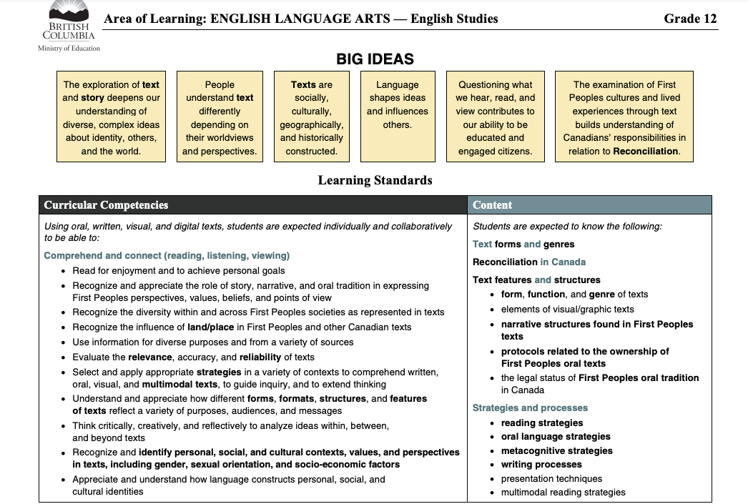

What are we going to cover in this class?

This list is not extensive and may change. The main topics covered in this class include, but aren’t limited to:

- Literary Terms (such as paradoxes, oxymorons, and others)
- Indigenous Content (a short story by Thomas King accompanied by an analysis of artwork by Indigenous creators)
- Poetry (a sonnet or another selected poem)
- Preparation for the Literacy Assessment (the format will be discussed in class and amended as needed)
- Paragraph writing
- Textual analysis
- Multimedia analysis
- A novel study unit (The Catcher in the Rye by J.D Salinger)
- Other topics that may be included to support the class, such as various grammatical structures or writing techniques
- Vocabulary building

Evaluation Scheme
Quizzes and Tests  15% | Participation  10% | Final  20% | Midterm  20% | Note checks, classwork, or homework  5% | Assignments and Projects  30%
*Important note about the Evaluation Scheme: This semester has an amended evaluation scheme. The Evaluation Scheme is not the same as some previous semesters, so please familiarize yourself with it.

Important points to remember:
- Plagiarism negates points!
- Remember to raise your hand in class.
- Participation must be productive, not destructive. Just speaking all the time in class does not qualify as productive participation. Your participation must contribute something positive to the discussion and not distract the class. You must also practice active and attentive listening. Listening to others is just as important as speaking.
- Disagreeing with someone is completely acceptable, as long as you focus on the idea and not the person.
- We respect people of all backgrounds in this class. Please keep this in mind. Bullying is any form is not tolerated.

Additional Guidelines:
- ATTENDANCE & PUNCTUALITY
  - Be on time and notify the teacher when you will be absent. Do not ever leave campus without permission during school hours in-case of an emergency.
  - If you are sick, notify the teacher via email and do not come to class. You will require proof of sickness in the form of a note that is either signed by your parent, home-stay guardian or a doctor. You must also leave a contact number for the person who signs the note for verification purposes.
- PLAGIARISM AND ACADEMIC DISHONESTY
  - Plagiarism and academic dishonesty cannot be tolerated under any circumstance. From the Teacher’s perspective, it is very simple to recognize when a student is not using original work. If you do not understand how NOT to plagiarize, please speak to me privately so I can show you! Multiple occurrences must and will be reported to the principal.
- MISSED WORK & GRADES
  - Ultimately, if you have missing work your grades will be negatively affected. I will always give students the chance to make up work (within reasonable circumstance) to earn better marks. However, be prepared to defend your position as to why you should have the privilege to re-do, complete extra or make up missed work. If you miss a course-work deadline and subsequently skip your make-up date, you will be awarded a zero – no exceptions.

For more information, please email Ms.Subramaniam at jyotsna.subramaniam@pattisonhighschool.ca

